Experiment 3 – Exploratory Data Analysis (EDA): Data Cleaning and Data Transformation

Aim:

To identify and handle missing values, duplicate records, outliers, and inconsistent data, and perform data transformation techniques such as normalization and encoding using Python Pandas on the Driver Standings.

Procedure:

Import the required Python libraries such as Pandas, NumPy, Matplotlib, and Scikit-learn.

Load the driver_standings.csv dataset into a Pandas DataFrame.

Display the dataset information and identify missing values.

Count the number of missing values in each column.

Handle missing values by replacing numerical columns with their mean and categorical columns with their mode.

Identify duplicate records and remove them.

Detect outliers in numerical columns using the Interquartile Range (IQR) method.

Visualize outliers using a box plot.

Normalize numerical features using Min-Max Scaling.

Encode categorical variables using Label Encoding.

Perform One-Hot Encoding on another categorical feature.

Display the cleaned and transformed Driver Standings dataset.

Code: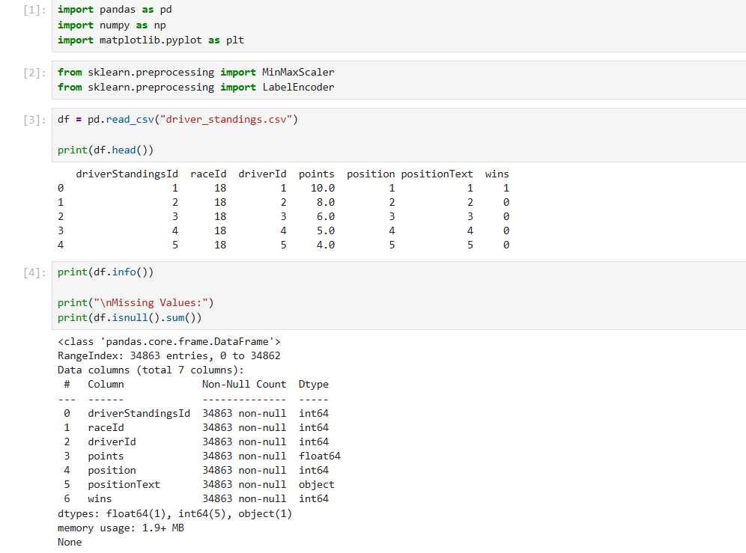
- Import necessary libraries and read the dataset
- Check if the dataset has missing values
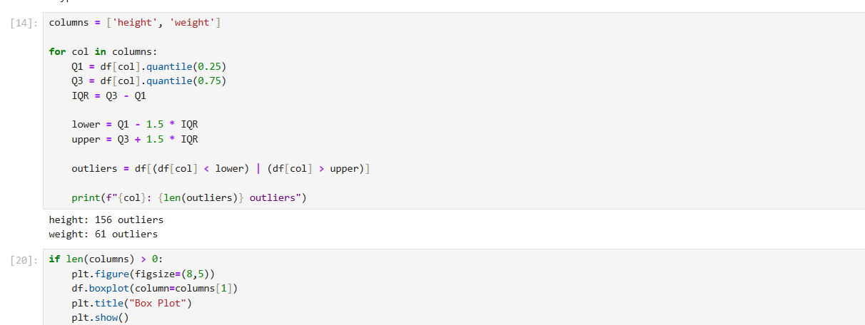
- Detect number of Outliers Using IQR
- Show the weight columns outlier in boxplot

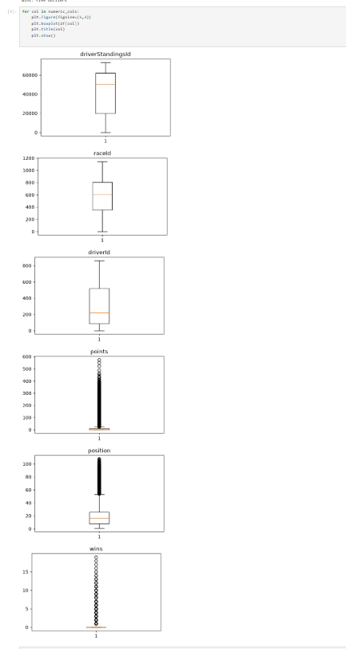

- Display Box Plot for Numerical Columns
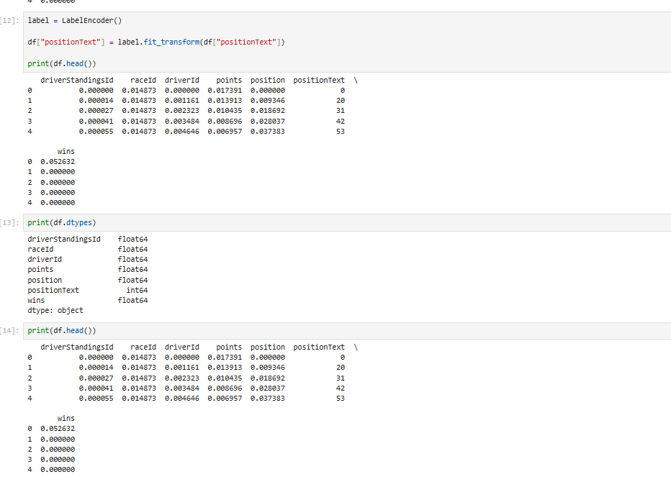

- Perform One-Hot Encoding on the sample categorical column
- Display the data types of all columns in the dataset
- Display the cleaned and transformed Player dataset

